Lab 4

**GitLab Installation Lab on Ubuntu VM**

**Prerequisites**

* Ubuntu 20.04 or 22.04 VM (recommended)
* At least 4 GB RAM and 2 CPUs
* Root or sudo access
* Internet access
* A hostname pointing to your VM's IP (e.g., gitlab.example.com) – optional but recommended for external access

**Step 1: Update Your System**

sudo apt update && sudo apt upgrade -y

**Step 2: Install Required Dependencies**

sudo apt install -y curl openssh-server ca-certificates tzdata perl

sudo apt install -y postfix

**Step 3: Add GitLab Repository**

curl https://packages.gitlab.com/install/repositories/gitlab/gitlab-ee/script.deb.sh | sudo bash

**Step 4: Install GitLab**

Replace http://gitlab.example.com with your actual domain or public IP:

sudo EXTERNAL_URL="http://gitlab.example.com" apt install -y gitlab-ee

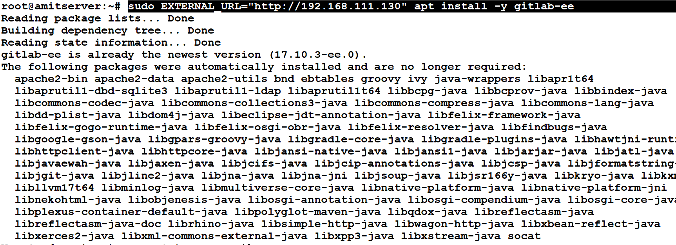

**Step 5: Configure GitLab**

sudo gitlab-ctl reconfigure

This may take a few minutes. It will set up NGINX, PostgreSQL, Redis, and other required components.

**Step 6: Access GitLab**

Open a browser and go to:

http://<your-domain-or-ip>

**Default Admin User**

* **Username:** root
* **Password location: /etc/gitlab/initial_root_password**

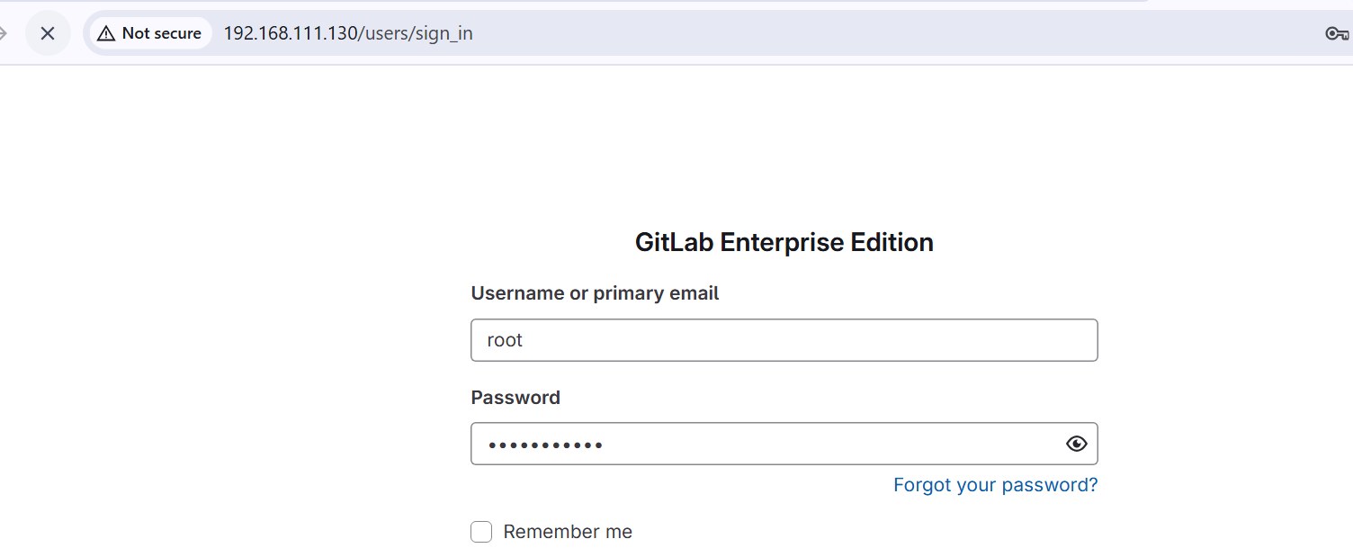

On the first visit, GitLab will ask you to set the **admin password**.